**Report on Simulink model**

**Objective:** Validation of high voltage system using MATLAB Simulink.

**Target:** To find motor and battery specifications using MATLAB Simulink.

**Input:** Drive cycle (Velocity vs Time).

**Output:** Motor and battery specifications(Power/Torque/RPM vs Time,C rating of cell) according to drive cycle.

MATLAB script for input parameters-

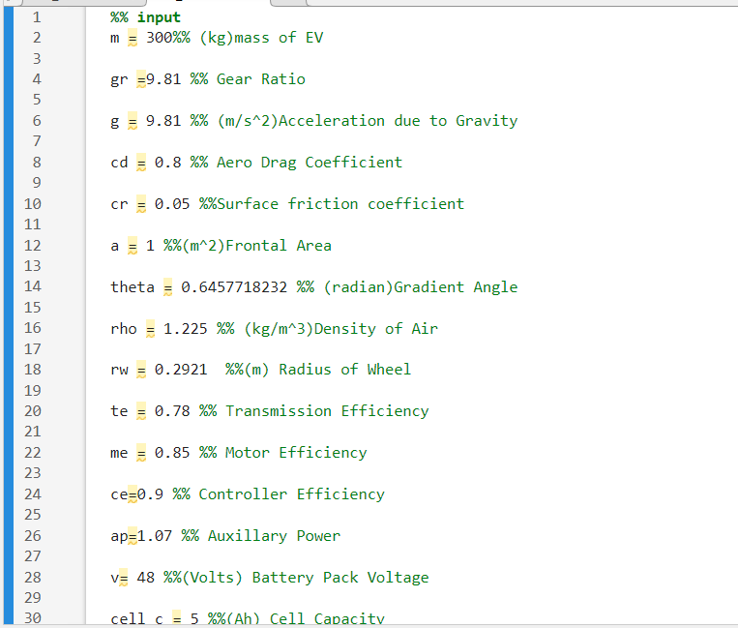

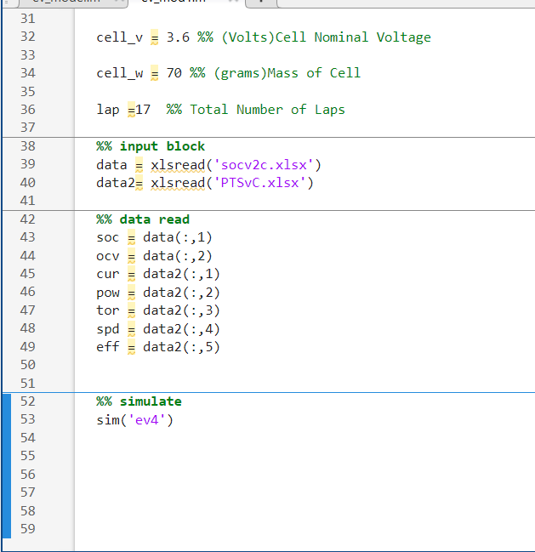

Motor specification:

|  |  |
| --- | --- |
| Type | PMSM Motor |
| Power | Peak-7.2 KW  Rated- 5KW |
| Speed | 3900-4500 Rpm |
| Torque | Peak-75 N.m  Rated-25 N.m |

**Formulas used:**

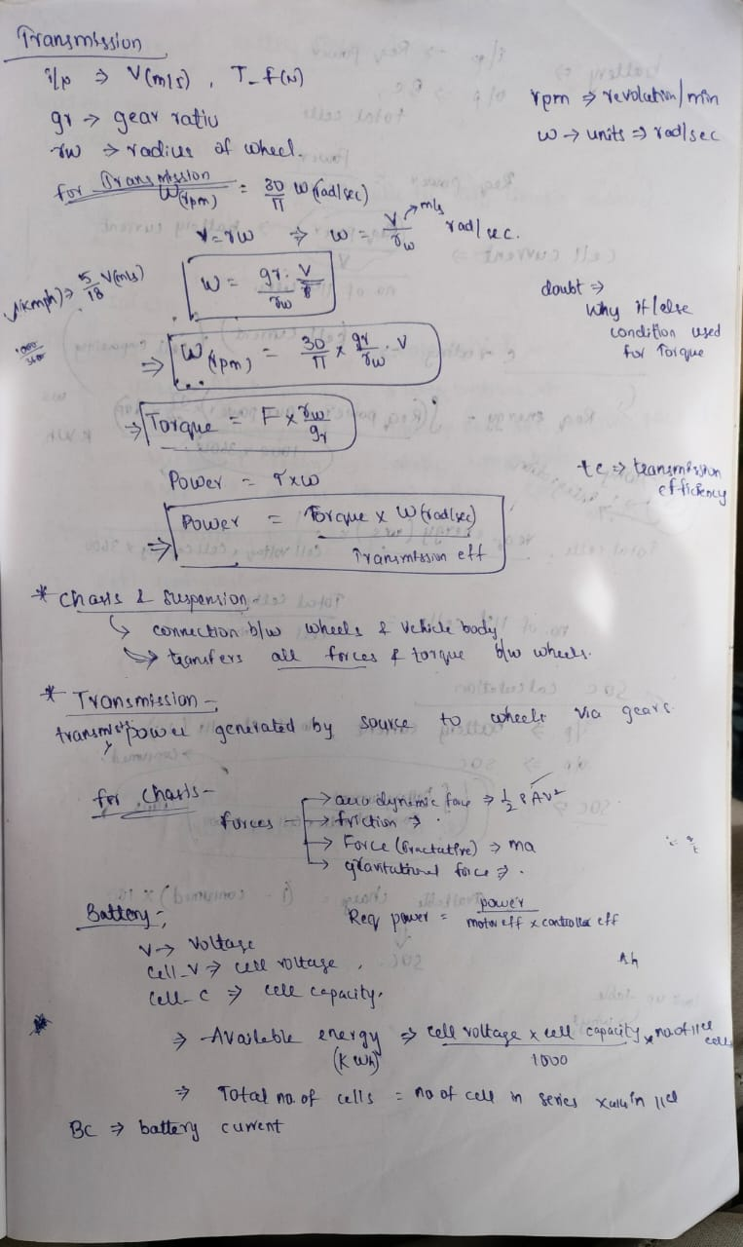

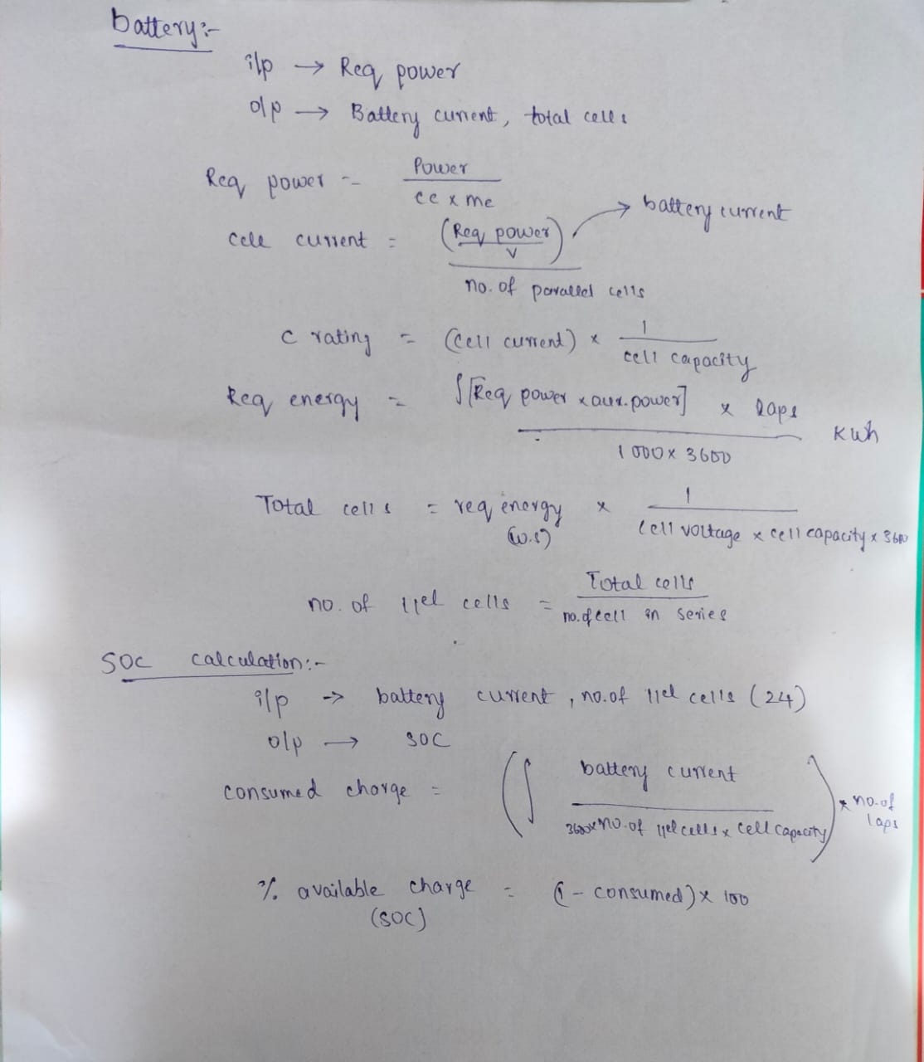

Block diagram:

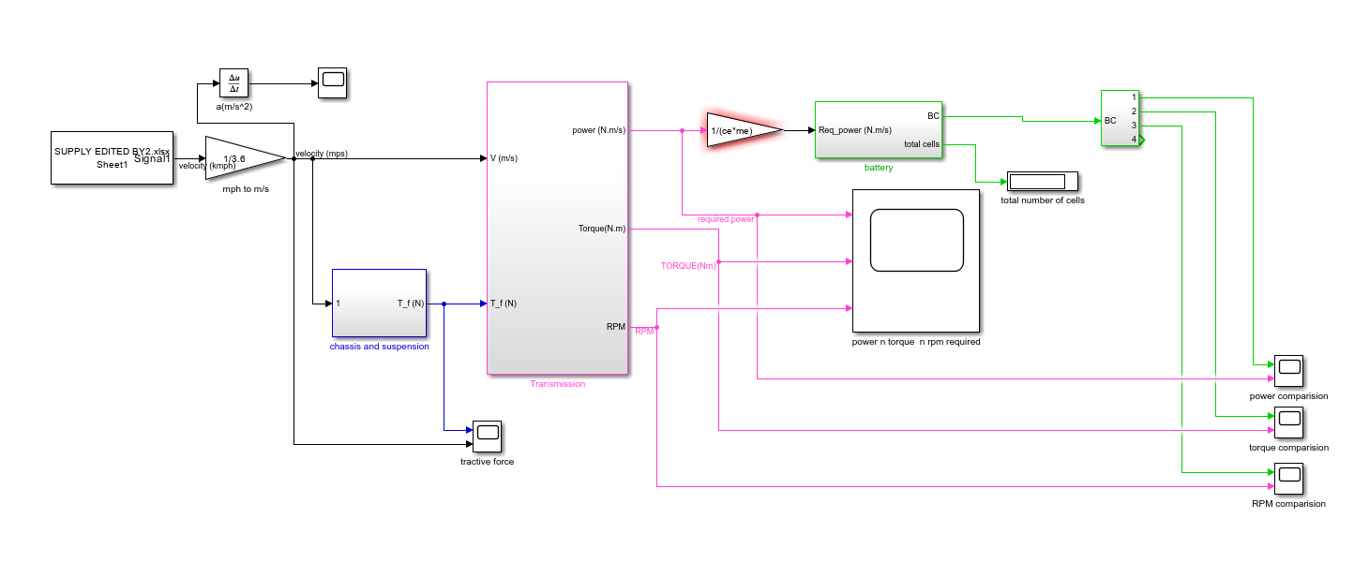

**Chassis and Suspension block:**

**Input:** Drive cycle in m/s.

**Output:** Tractive force(N).

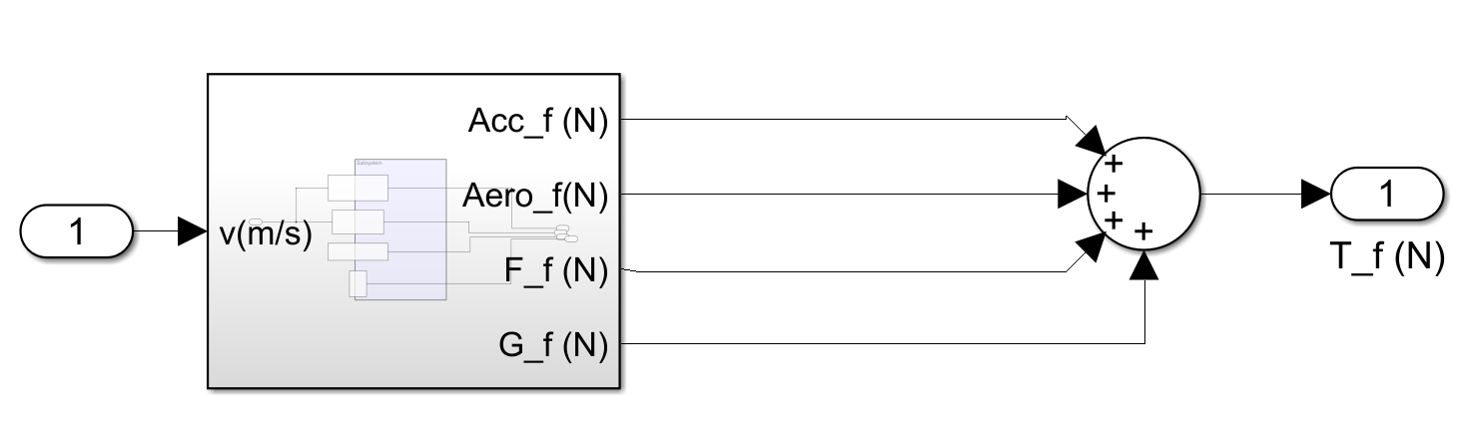

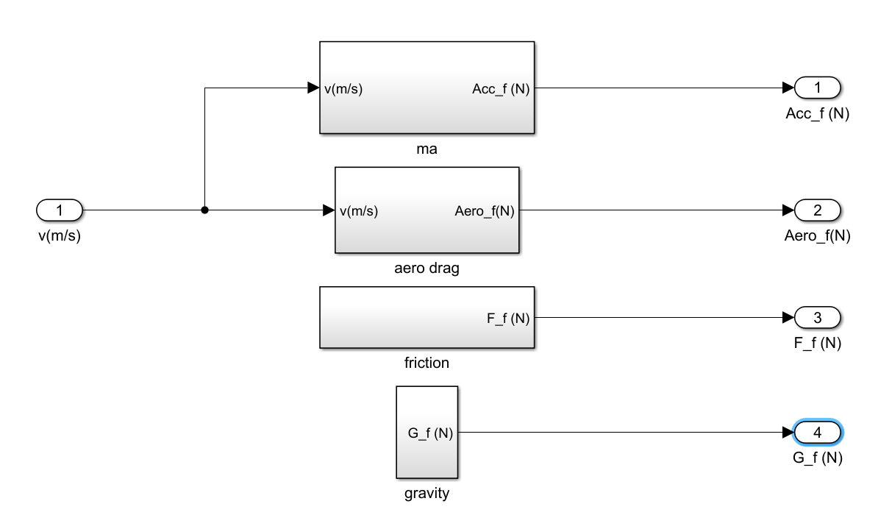

**Transmission block:**

**Input:** Drive cycle(m/s) , Tractive force(N).

**Output:** Required power,Torque and RPM.

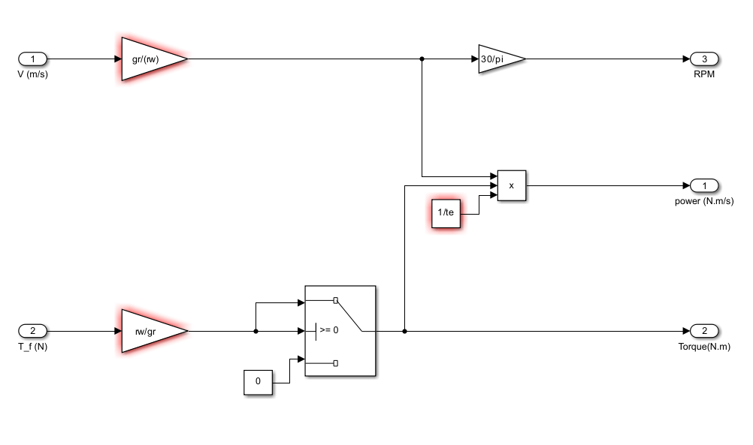

**Battery Block:**

**Input:** Required Power(N.m/s).

**Output:** Battery current and Total cells.

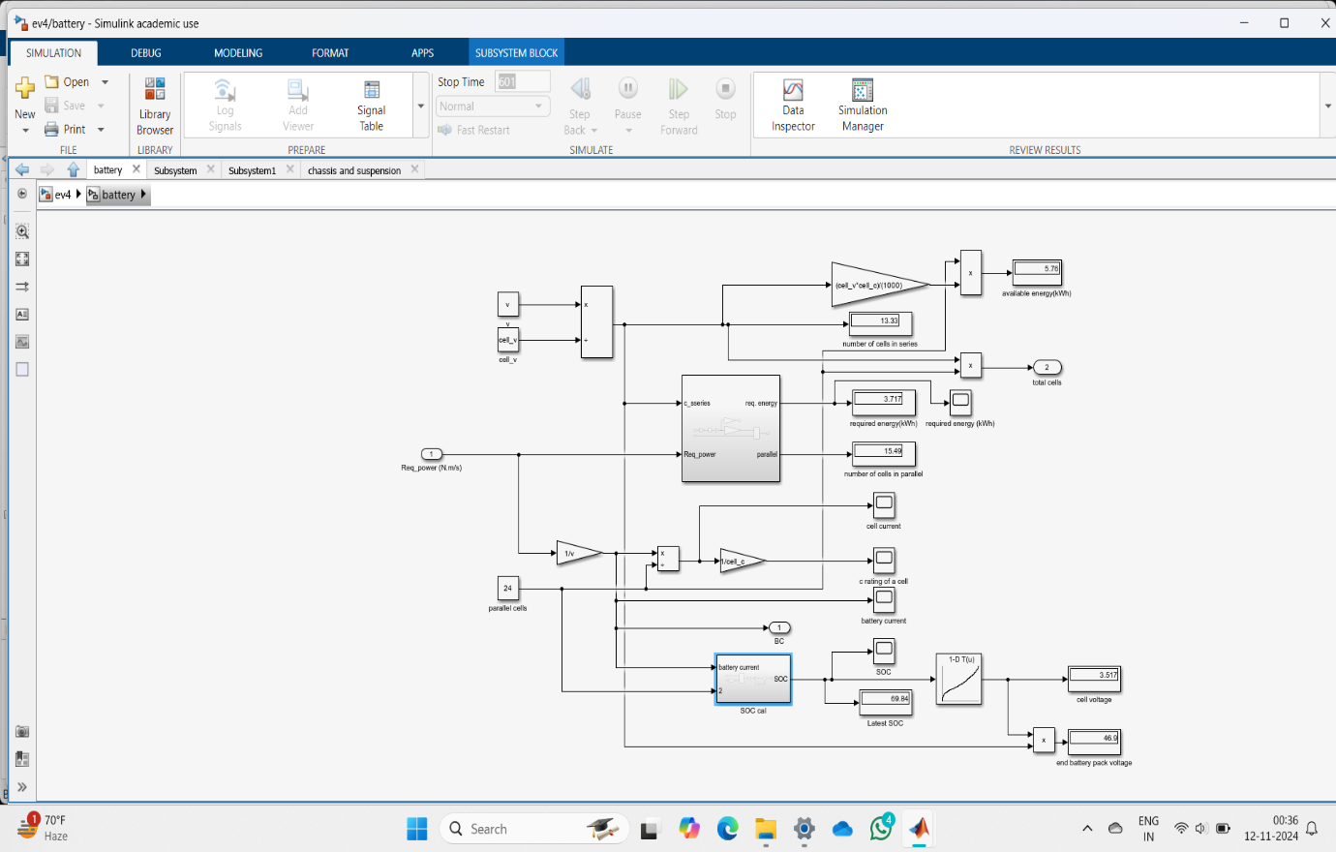

SOC calculation:

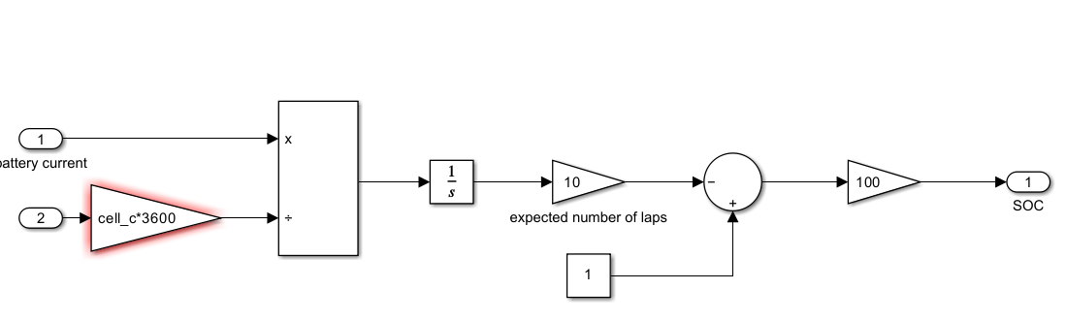 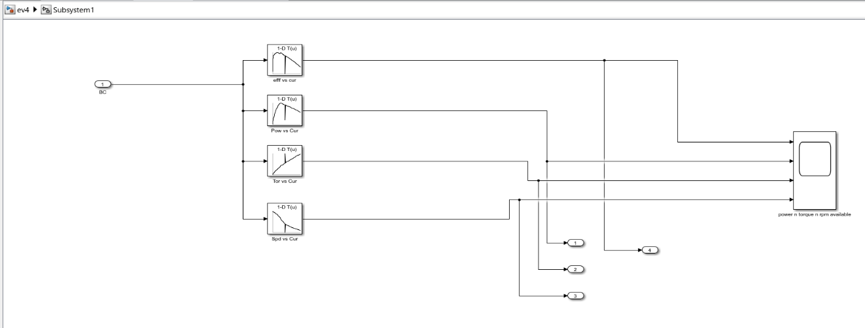

**Simulation results:**

1.RPM comparison (available vs required):

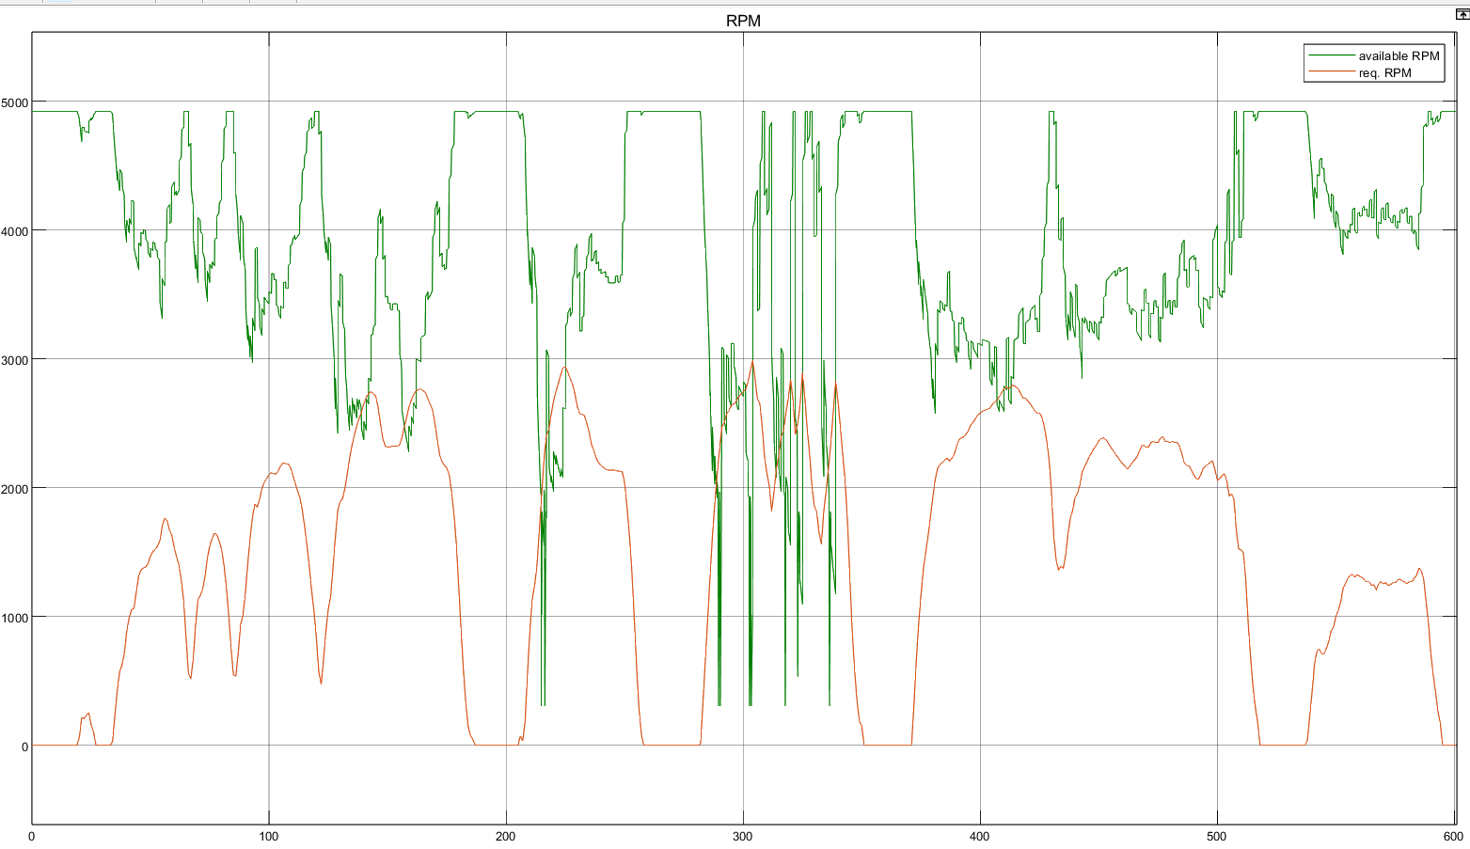

2. Power comparison:

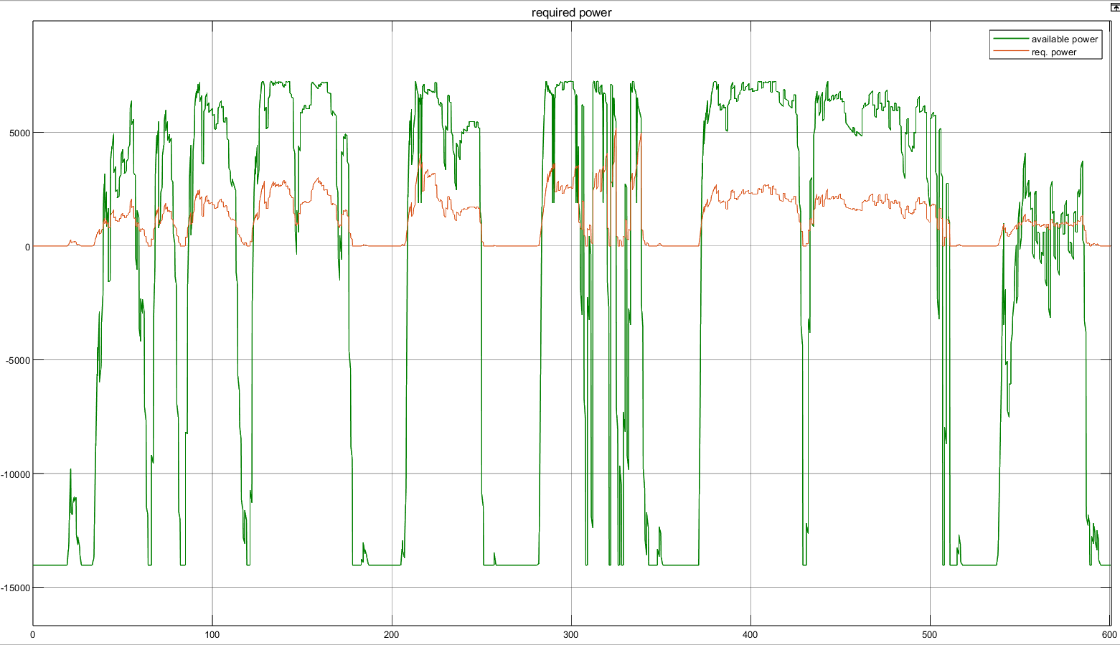

3.Torque comparison:

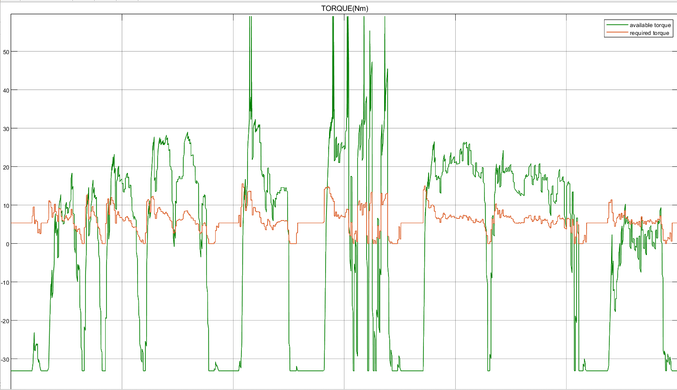

4.Cell current:

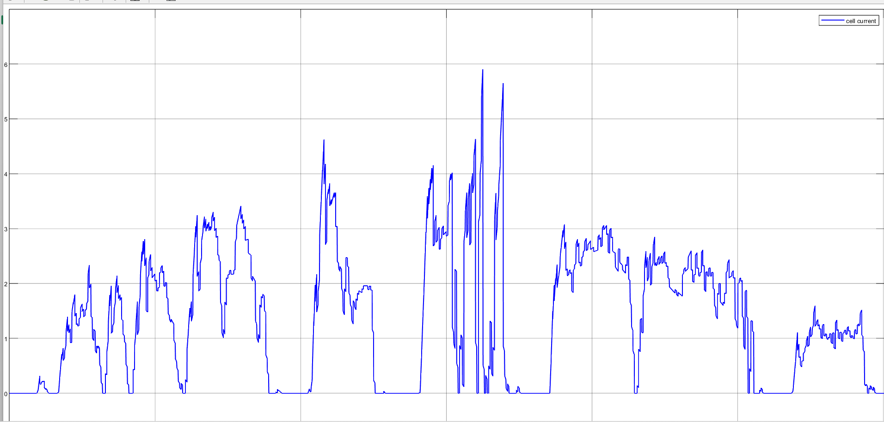

5.C rate:

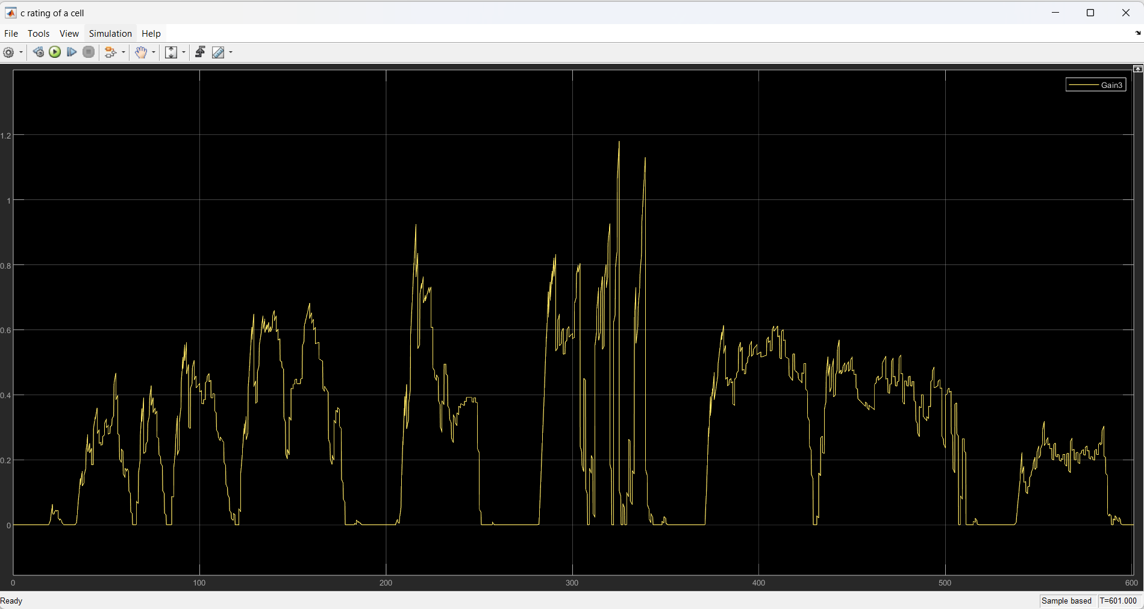

6.Chassis and Suspension:

Tractive force & Velocity vs Time-

